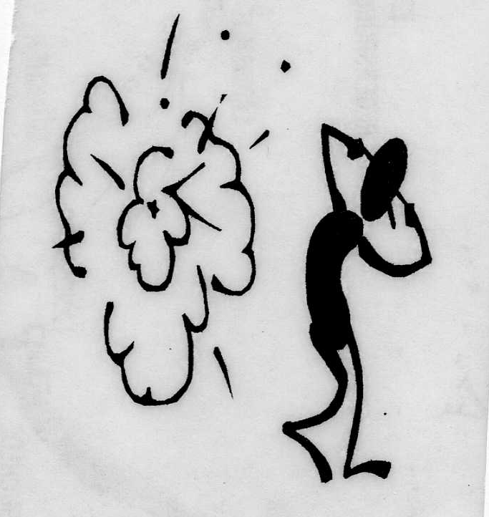

Like the man who was tarred and feathered
and ridden out of town on a rail said when asked how he felt about it,
“If it had not been for the honor, I just as soon not have done it.”

By

Jack Durrance

