About the Author

During World War II, John R. “Jack” Durrance served as a Staff Sergeant with the 103d Infantry Division in the European Theatre of Operations, and was later commissioned as a Second Lieutenant. He was awarded the Bronze Star, two Purple Hearts, three Battle Stars, Glider Wings, Paratrooper Badge and the Combat Infantryman’s Badge. He is married to Janet Hiers Durrance and has four children and eight grandchildren.

He received his Bachelor and Masters degrees from the University of Florida where he taught as a faculty member while working toward a doctorate, which he did not complete.

He was employed by the United States Navy as a psychologist at the Jacksonville Navel Air Station in Jacksonville, Florida prior to becoming a Special Agent for the Federal Bureau of Investigation in the New York City area. He was an Alachua County Commissioner in Florida from 1954 to 1982. He has been retired since selling his ownership in a warehouse and trucking business in 1984.

58

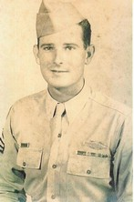

John R. ‘Jack’ Durrance - 1945

59
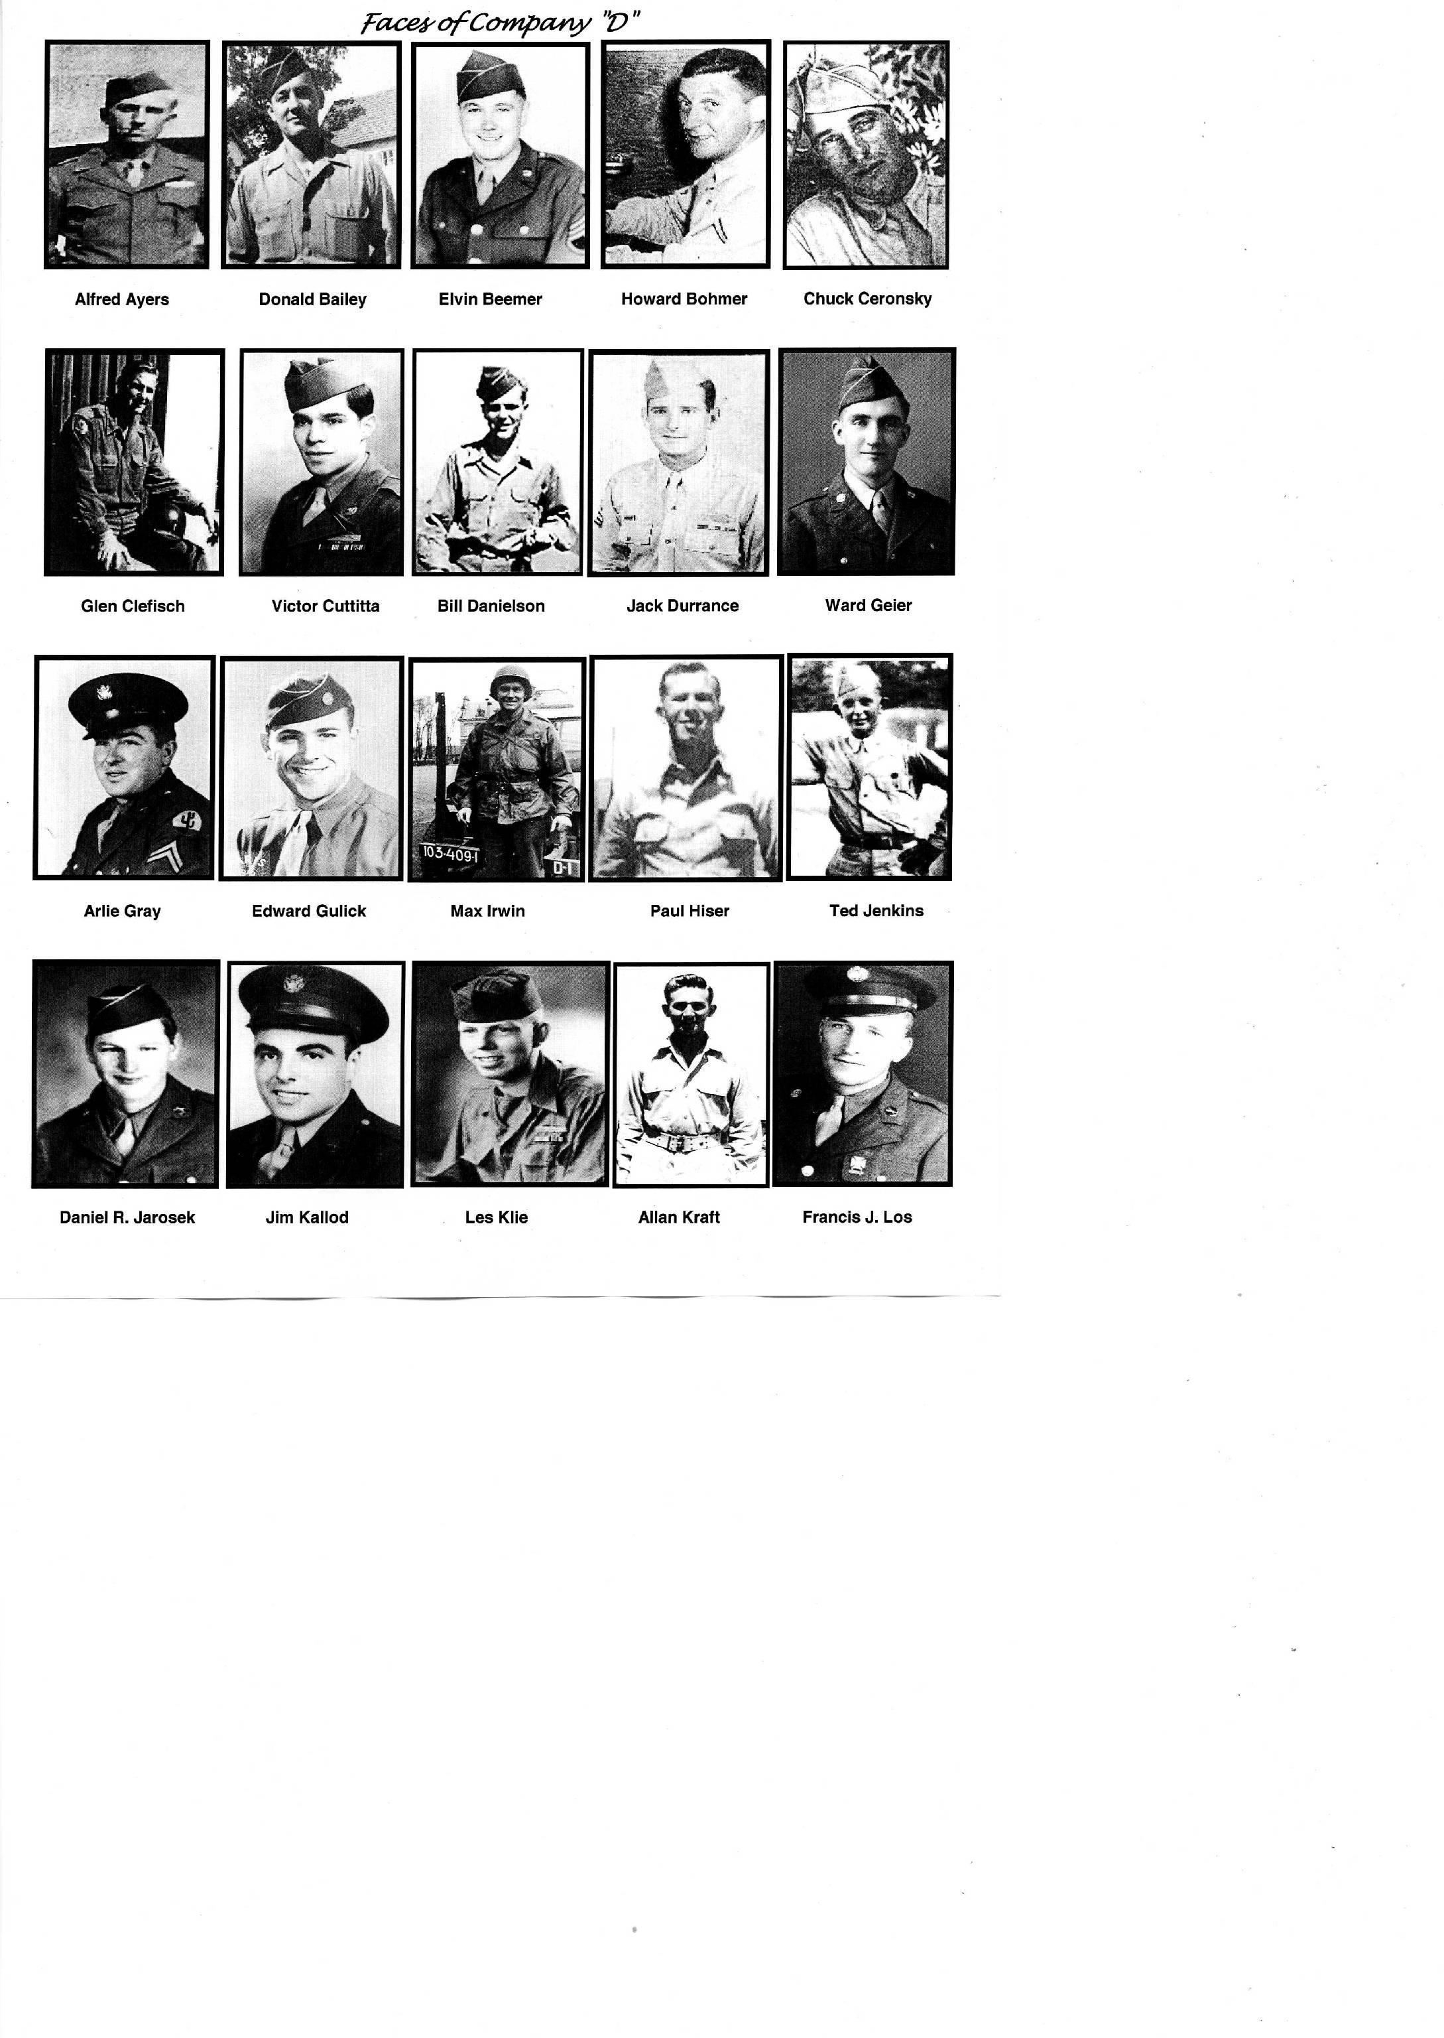
60
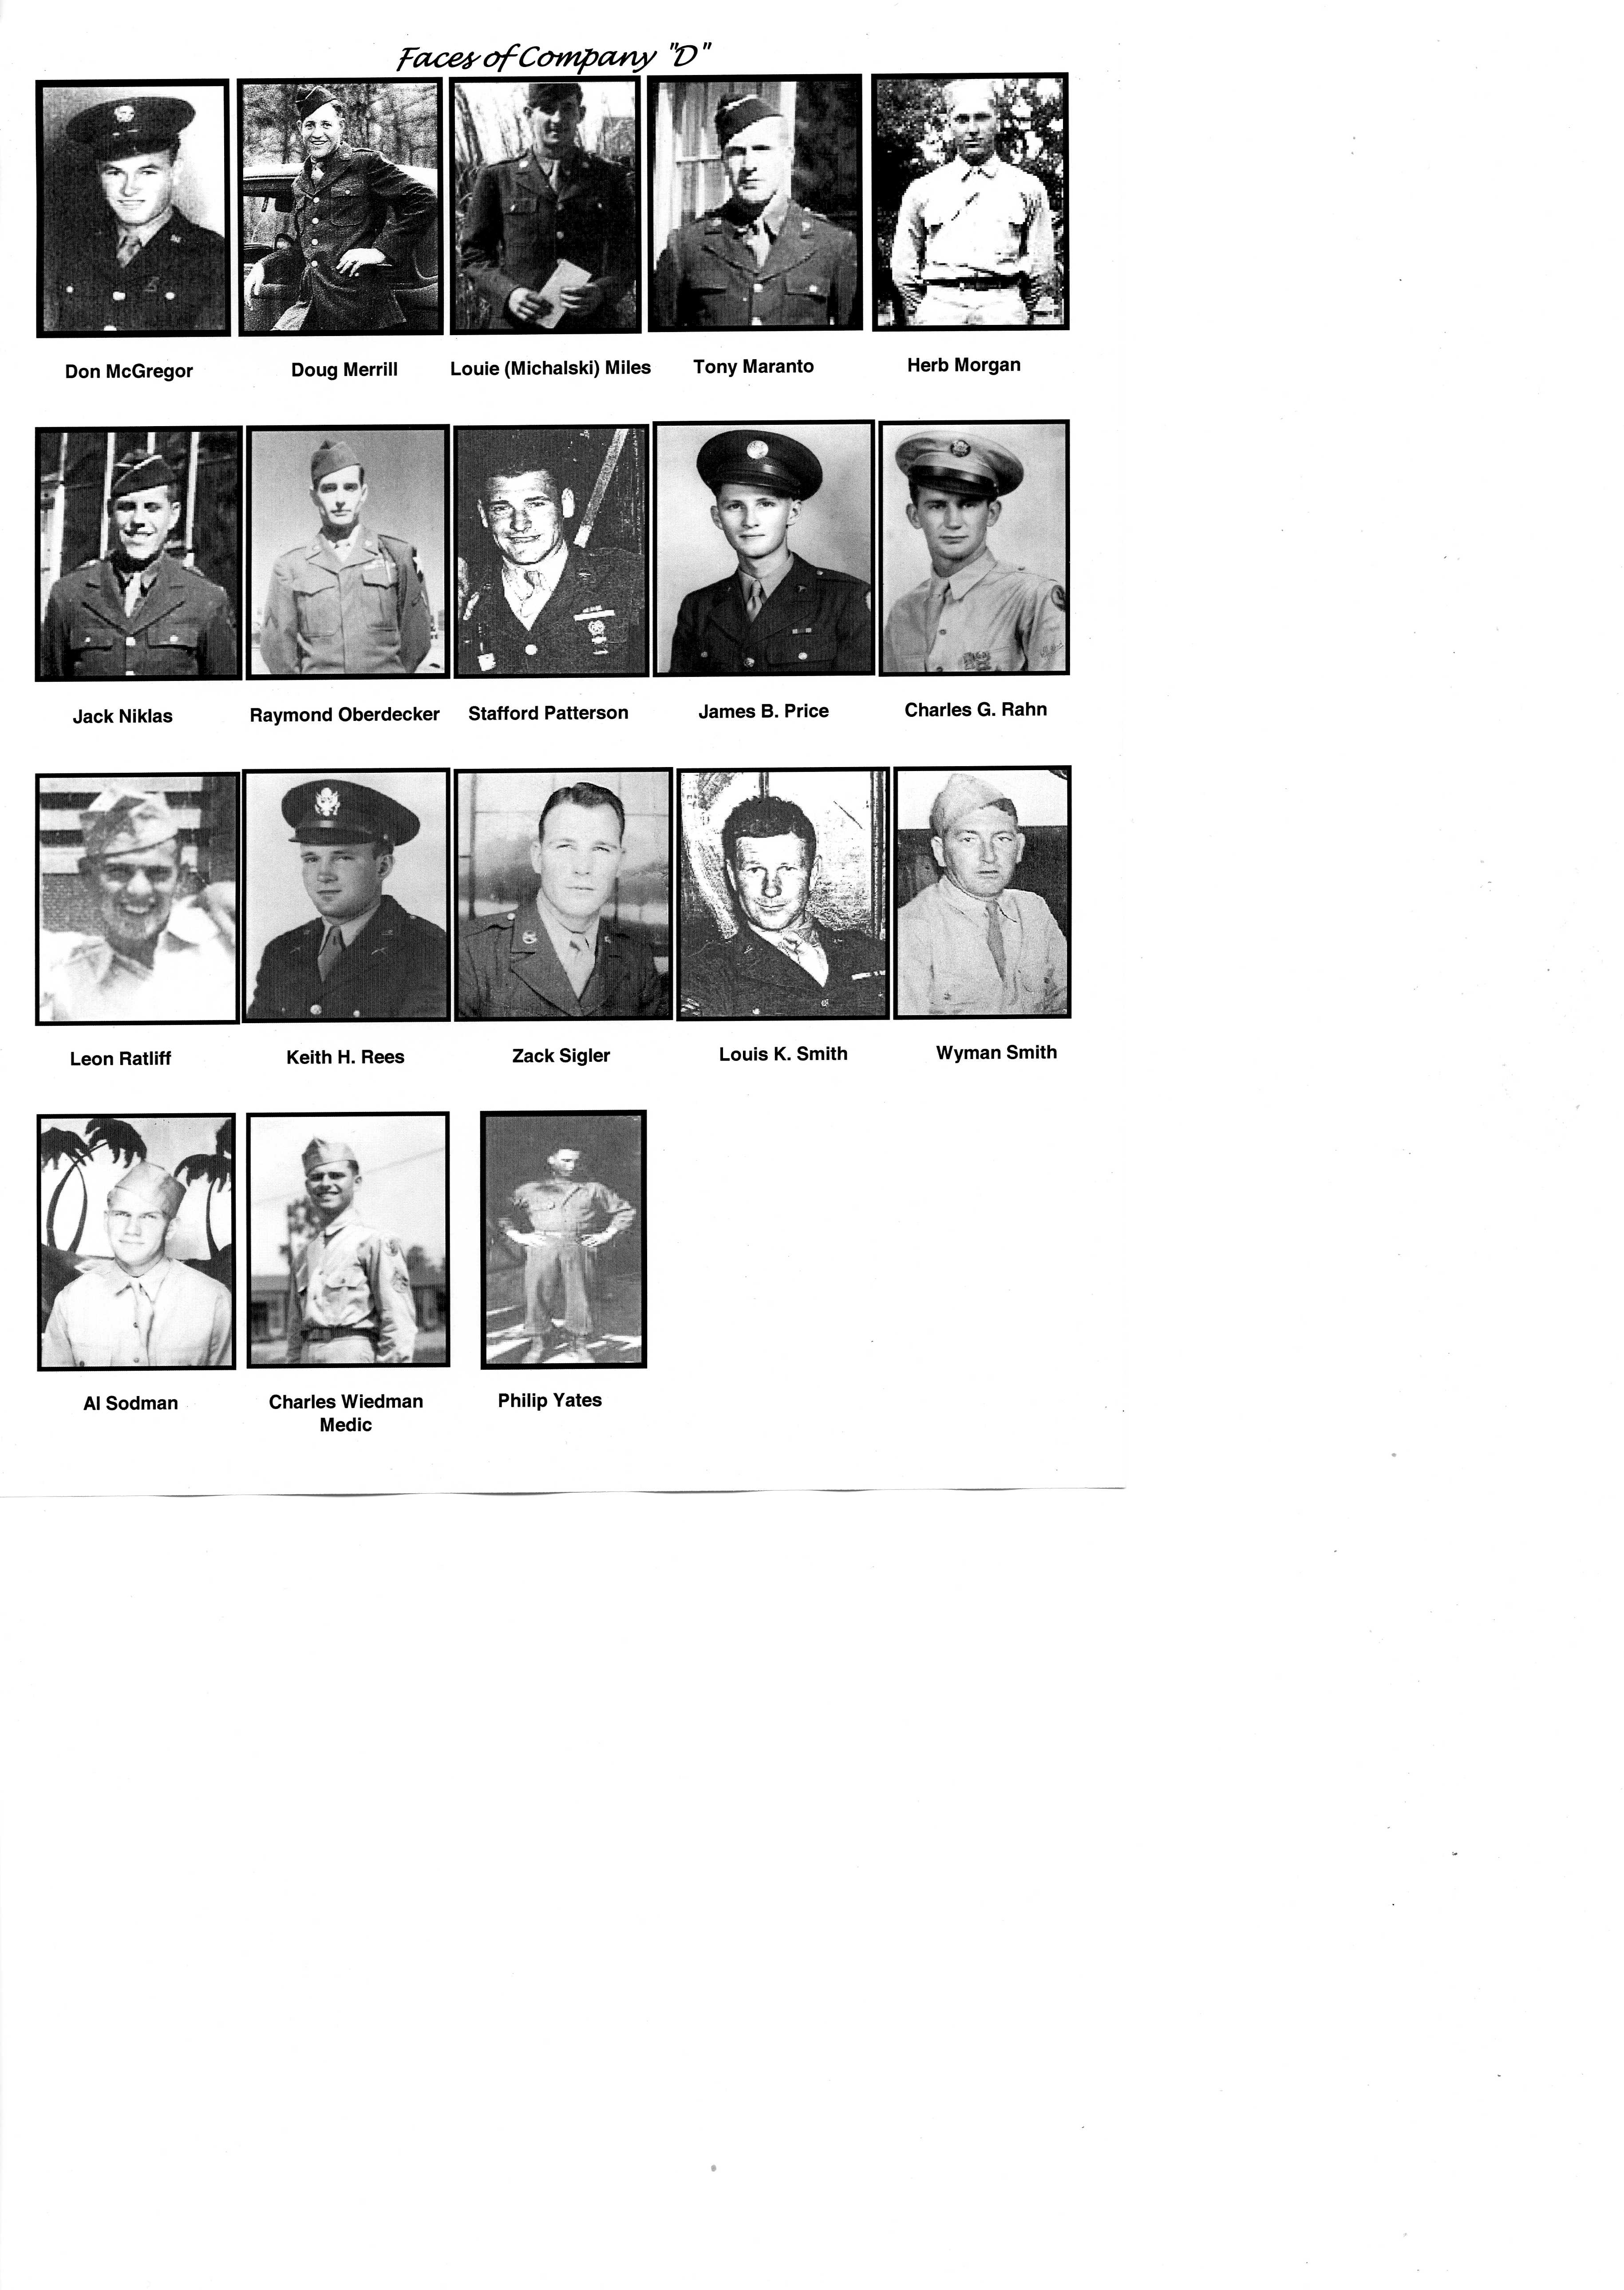
61

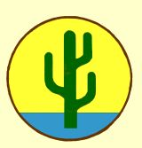

103d Division
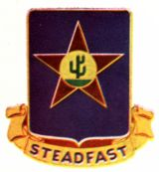

409th Regiment
Company D

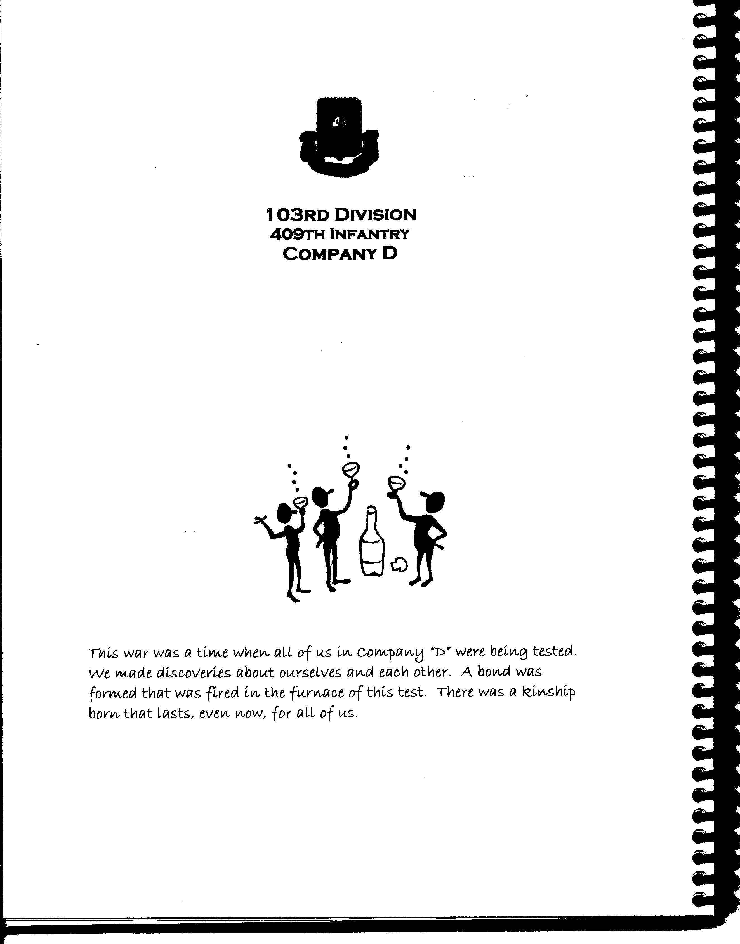

“This war was a time when all of us in Company “D” were being tested.
We made discoveries about ourselves and each other.
A bond was formed that was fired in the furnace of this test.
There was a kinship born that lasts, even now, for all of us.”

