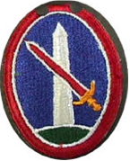

THE MILITARY “CAREER” of

John E. Walters

B-Co, 410th
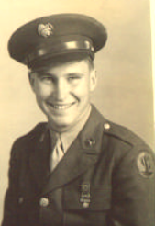

Captured at Itterswiller – November 30, 1944

